Periodic Progress Meeting #1

Meeting 1 — Initial Project Discussion
Date | 16 February 2026
Supervisor | Dr Mohammad Al-Ibaisi
Student | Tatenda Marimo
P-Number | P2964932
Next Meeting

What Was Discussed
I presented the initial SuiLoyalty project overview document covering the full proposed scope: a blockchain-powered Dynamic NFT loyalty system on the Sui Network. The document outlined the problem statement, proposed solution, 7 technical objectives, technology stack, 15-week sprint timeline, and expected deliverables.

Document Presented
- SuiLoyalty — Blockchain-Powered Dynamic NFT Loyalty System (project overview document)
- The original scope included the following: Move smart contracts, HMAC-SHA256 QR authentication, the brand dashboard, the consumer PWA, and k6 performance testing.

Supervisor Feedback & Decisions
- Overall project concept approved.
- Suggestion: Database design to be added to Sprint 1 (Weeks 3–4) alongside the move smart contract work. Dr Al-Ibaisi noted that designing the PostgreSQL schema early avoids rework later when the backend is built in Sprint 2.

Student Signature: | Supervisor Signature:
Tatenda Marimo | 16/02/2026 | | Date: __16/2/2026__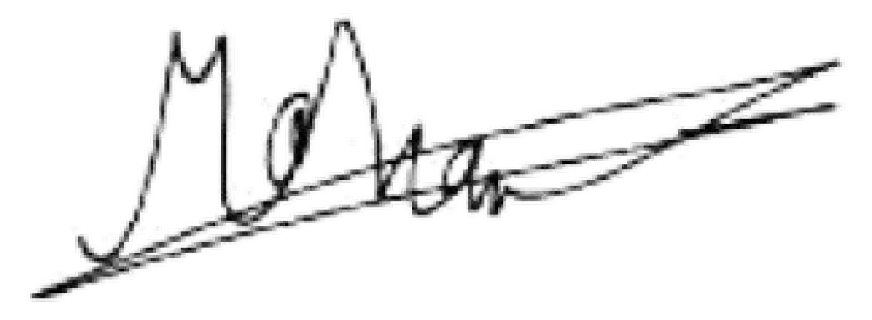

Periodic Progress Meeting #2
Meeting 2 — Scope Review
Date | 12 March 2026
Supervisor | Dr Mohammad Al-Ibaisi
Student | Tatenda Marimo
P-Number | P2964932
Next Meeting

What Was Discussed
Dr Al-Ibaisi reviewed the project overview and project contract submitted on 11 March 2026 and provided feedback requesting a number of scope simplifications.

Supervisor Feedback & Decisions
- Brand dashboard was removed entirely from scope — not required to demonstrate the core blockchain and zkLogin objectives.
- QR authentication simplified — HMAC-SHA256 cryptographic tokens replaced with unique
UUID tokens stored in PostgreSQL. A simple used/unused check in the database is sufficient.
- k6 load testing removed — performance benchmarking (50 concurrent users) is not required for the scope of this project.
- Security analysis simplified — OWASP threat modelling removed. Basic security validation (QR replay prevention, JWT verification) is sufficient.
- Usability testing changed to informal and optional — a formal SUS questionnaire with 10–15 participants is not required. Informal feedback on the zkLogin flow if time and participants are available.
- Sprint schedule compressed from 7 sprints to 5 sprints plus a buffer, ending Week 14.


Student Signature:

Supervisor Signature:

Tatenda Marimo | 12/03/2026

Dr Al
-
Ibaisi | Date: ___________

^{12/03/2026}

Periodic Progress Meeting #3
Meeting 3 — Scope Review
Date | 23 April 2026
Supervisor | Dr Mohammad Al-Ibaisi
Student | Tatenda Marimo
P-Number | P2964932
Next Meeting | Next Week

What Was Discussed
I presented the database design document and gave a progress update covering three completed development sprints. I demonstrated the working system live on Sui testnet and discussed on working on the QR scan flow and on-chain NFT update. SuiLoyalty Database Design, updated with Universal Avatar architecture, 7 tables, system architecture diagram, multi-brand flow diagram, and ERD with multiplicity notation
Progress Update Presented
- Sprint 1 complete — Move smart contracts deployed to Sui testnet. LoyaltyAvatar NFT with Dynamic Object Fields, AdminCap pattern, and loyalty token working
- Sprint 2 complete — Node.js backend with zkLogin Google authentication working end to end. QR validation with atomic replay prevention
- Sprint 3 complete — Consumer PWA with Google Sign-In, QR scanner, and multi-brand dashboard. Merchant terminal for batch QR code generation

Supervisor Feedback & Decisions
- Dr Al-Ibaisi provided report structure guidance — Introduction, Literature Review, Design, Implementation, Testing, Evaluation, Critical Reflection
- Recommended outlining chapters before writing
- Literature Review should critically compare blockchain loyalty systems and justify Sui choice
- Critical Reflection should honestly evaluate whether blockchain was the right choice

Student Signature:

Supervisor Signature:

Tatenda Marimo | 23/04/2026

Dr Al
-
Ibaisi | Date: ___________

Periodic Progress Meeting #4
Meeting 4 — Scope Review
Date
Supervisor | Dr Mohammad Al-Ibaisi
Student | Tatenda Marimo
P-Number | P2964932
Next Meeting

